
Name: _____________________________________

Oreo Mitosis Lab
Materials
6 or 7 Oreos per group
2 Tablespoons of rod-shaped coloured sprinkles
6 Toothpicks per group

Procedure
1. Using your notes or your textbook, find images of the cell cycle that include: interphase, mitosis (prophase, metaphase, anaphase, and telophase) and cytokinesis.
2. Using the images found, create a model for each bolded stage of the cell cycle listed above.
3. Carefully remove the top cookie from all six cookies by twisting the top cookie in a circular motion while holding the bottom cookie with your other hand. The bottom cookie with the cream filling attached will be used for your models. (Note: You may eat the top cookie, or lay it aside.)
4. Place the cookies on a paper towel or a blank piece of paper.
5. The cream filling represents the cytoplasm of the cell. You must create the structures inside the cell that play a role in the cell cycle by using candy sprinkles to represent the chromosome pairs and other sprinkles to represent the spindle fibres, centrioles, nuclear membrane, etc.
6. The toothpicks may be used to remove or divide the cytoplasm or to move around the sprinkles.
7. Once you have created a model for each stage of the cell cycle, summarize what is happening in each stage in the table below.

Stage | Summary of Important Events
Interphase
Prophase
Metaphase
Anaphase
Telophase
Cytokinesis

8. Label the following on your paper towel: Interphase, Prophase, Metaphase, Anaphase, Telophase,
Cytokinesis. Also include a key for the sprinkles (for example: what colour are the spindle
fibres, centrioles, etc..).
9. Once your teacher confirms that your models and summary are accurate, take a photo and insert it below. You and your group may consume what remains of your Oreo cookie models.
10. Clean-up: Discard all materials from your lab once your teachers approve of your models and summary. Wipe off all surfaces to remove crumbs.

How creative are you? Can you think of a sentence to help you remember the order of events in the cell cycle?
Example: In private, my Algebra teacher cries.

I-___________ P-____________ M-____________ A-____________ T-____________ C-____________

Analysis
1. During which phase of mitosis do the sister chromatids split apart and move toward the poles of the cell?

2. During which phase of mitosis does the nuclear membrane reappear around the newly formed sets of chromosomes?

3. When are the chromosomes copied?

4. From what structures do the spindles originate?

5. What is the difference between cytokinesis in plant and animal cells?

6. When does the cytoplasm divide?

Some Suggestions
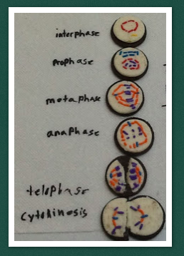
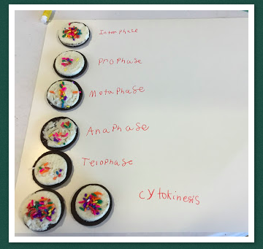

My Photo

